Tips & Hints
Cognos Training – Report Writing

- URLs for Cognos:
- Cognos-DEV – https://cognos-dev.udel.edu/cognos8

- Cognos (production) - https://cognos.udel.edu/cognos8
Or from Institutional Research’s UDEW page http://www.udel.edu/IR/UDEW/

- Join the Cognos mail list - https://udel.edu/mailman/listinfo/ud-cognos
  - Used to keep Cognos users informed about database issues, to report errors, etc.

- Problems/questions about Cognos, email experts in IR: ir-udew-it@udel.edu

- Two ways to run reports (if you have access to Report Studio):
  - Cognos Connection
  - Report Studio

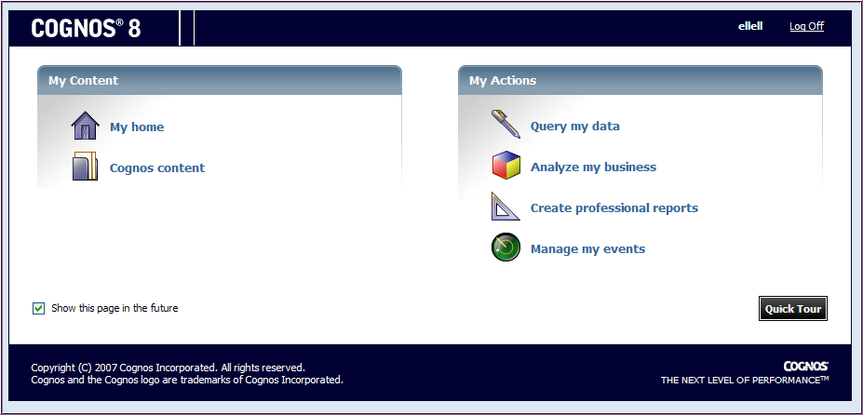
Takes you to Report Studio
Takes you to Cognos Connection
- Cognos Connection:
  - Navigate to My Folders or subject area folder in Public Folders
  - Find report and under Actions column, click Run with options
  - Choose HTLM, Excel, PDF, etc.
  - See: Cognos Level I Training for more details
- Report Studio:
  - Choose package from:
    - Recently used packages
    - or List of all packages
  - Click Allow Access button
  - Click Open an existing report or template
  - Navigate to My Folders or subject area folder in Public Folders
  - Double-click to open the report and wait for package to load
  - Click Run

- The dreaded “Unrecognized SOAP error” – Don’t let it happen to you!

This means you’ve lost your connection to the Cognos server and your work.
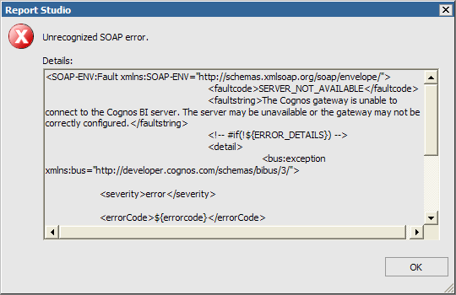
- You must logout of Cognos and log in again (not your browser, just Cognos)
- Possible reasons:
  - You’ve timed out due to “inactivity” for 30 minutes or more
    - “Inactivity” means anytime when you are not pulling data or sending data to the server
  - Bad network connection, especially with a wireless connection
- You will not be able to save your work (so sorry!)
- Save your work early & often!

- Delete vs. Cut:
  - Delete removes the data item from the report layout and the query. If you delete a data item, it will no longer appear on the Data Items tab. To add it back, go to the Source tab.
  - Cut removes the data item from the report layout but retains it in the query that Cognos uses to retrieve data from the source. To add it back, go to the Data Items tab.

- Cut vs. Delete – different effects with Page Explorer and Query Explorer

Page Explorer:
- Cut – removes a field from the report (Page Explorer), but retains it in the query (Query Explorer - data items pane)
- Delete – removes a field from both the report and the query

Query Explorer:
- Cut – removes a field from both the report and the query
- Delete – removes a field from both the report and the query

- Changing packages when creating a New report
Second, find the package you want and click the OK
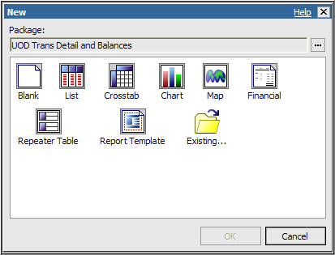
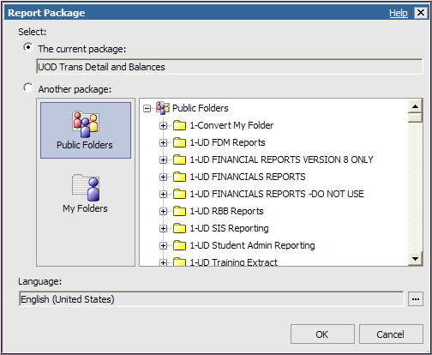

First, click the Ellipses

- Beware of unintentionally creating a “singleton” data element

A singleton is created when you drag a field into the work area to the wrong place.
GOOD
BAD
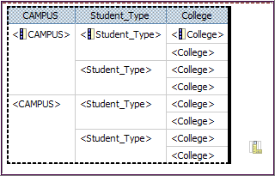 vs. 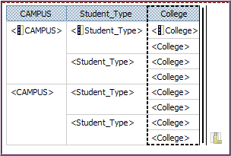
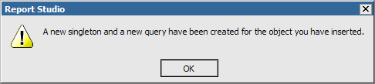
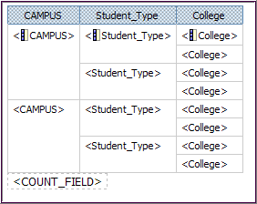 vs. 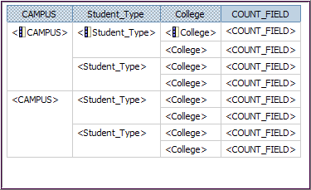
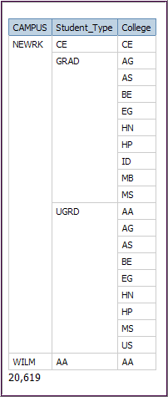 vs. 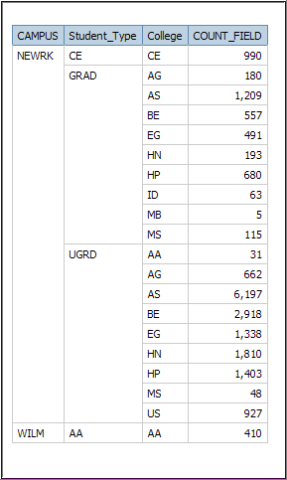
This is also the end of the report (no singleton).
This is the singleton at the end of the report.

- Hints for Filters
a. Writing Expressions
- Values will always be in ALL CAPS and have single quotes (e.g. ‘ABC’)

Equal (=) [DATA_ITEM] = ‘VALUE’

- If you don’t know the value for a data item, use the Select Value button
- Double-click a value to add it to the expression definition
- The value will be formatted correctly for the expression with single quotes
In list (in) [DATA_ITEM] in (‘VALUE’ , ‘VALUE’)

Not in list (not in) [DATA_ITEM] not in (‘VALUE’ , ‘VALUE’)

- If you don’t know the values for a data item, use the Select Multiple Values button
- Double-click a value to add it to the expression definition
- The values will be formatted correctly for the expression with single quotes and parentheses
b. Always Validate your Expression Definitions and look for “No errors.” This will save you frustration later if your report has problems; you will know the issue is NOT your filters.

c. Disable a Filter rather than deleting it.
- This gives you the option of re-using it at a later date

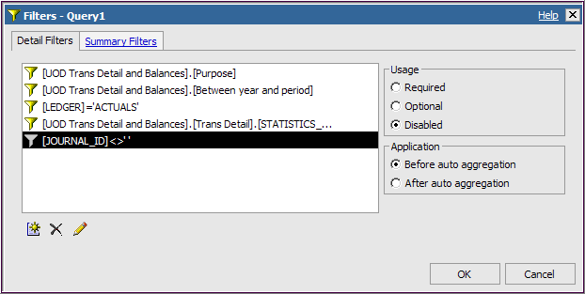

d. Re-use expressions from existing reports or other places
- You must use Copy [Ctrl-C] and Paste [Ctrl-V]
- You could keep a Word document with your frequently-used expressions to save time and avoid keying errors.
- Note that every Cognos package will need to have its own set of expressions.
  - For example the ones for the UOD Trans Detail and Balances package must be separate from the Contract and Grants Data Mart
e. Expressions – Dates
- Use the format yyyy-mm-dd

- Avoid having to choose prompt values over and over while building/running-building/running your report
  - Use Validate Report to set the prompt values
  - When the prompt page appears, you only have to click OK

- We strongly suggest you write your reports in Cognos-DEV and copy the good ones into Cognos (production) – you can do it yourself!
  - Everyone who gets access to write Cognos reports will get access to both DEV and Production databases
  - Helpful hint – select a different Style (color scheme) for DEV to distinguish it from PROD (See: Running Existing Reports, page 22)
  - This is how to copy a report from DEV to PROD:
    - Open the report in DEV, click Tools / Copy Report to Clipboard
    - Go to Cognos-PROD, open Report Studio
    - Click New report; choose same package as used in DEV
    - Click Tools / Open Report from Clipboard
    - Save the report with the same name (or not)

- Work with two instances of Report Studio when modifying a report (Use Copy to Clipboard instead of Save as)
  - This is how to copy a report from DEV to DEV (or PROD to PROD):
    - Your report is open in DEV (or PROD), click Tools / Copy Report to Clipboard
    - Go to Cognos 8 Welcome page, open Report Studio (click Create professional reports)
    - Click New report; choose same package as original report
    - Click Tools / Open Report from Clipboard
    - Save the report with a different name

- Two Ways to open an existing report to work on in Report Studio
  - Cognos Connection
  - Report Studio

Takes you to Report Studio
Takes you to Cognos Connection
- Choose Cognos Connection from Cognos8 welcome page:
  - Navigate to My Folders (or subject area folder in Public Folders)
  - Find report you want to work on
  - Under Actions column, click Open with Report Studio
  - When pop-up window appears, click Allow Access button
  - If this is a report from Public Folders:
    - Immediately save with a new name in My Folders
OR
- Choose Report Studio from Cognos8 welcome page:
  - Choose package from:
    - Recently used packages
    - or List of all packages
  - When pop-up window appears, click Allow Access button
  - Click Open an existing report or template
  - Choose My Folders (or subject area folder in Public Folders)
  - Double-click to open the report and wait for package to load
  - If this is a report from Public Folders:
    - Immediately save with a new name in My Folders
- Sort – how to view or change the sort order in a report
  - Click Sort
  - Choose Advanced Sorting…

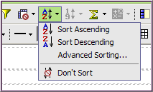

  - Change the sort order by:
    - Highlight a field under the Detail Sort or Groups list:
    - Use the green up/down arrows to change the order
    - Click OK

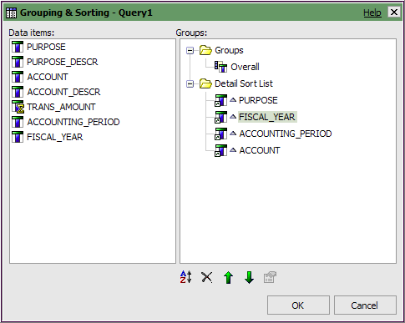

- Use My Area/My Preferences to customize “the look” of Cognos

My Preferences – Use this feature to set personal settings and defaults

- Change your List View to have alternating white and gray lines
- Change the color scheme with the Style (this is recommended when you are using both Cognos-DEV and Cognos-PROD)

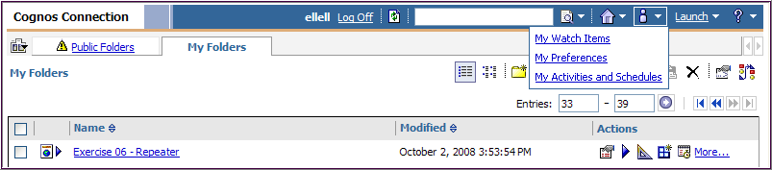
1. Click My Area and choose My Preferences

On the General tab:

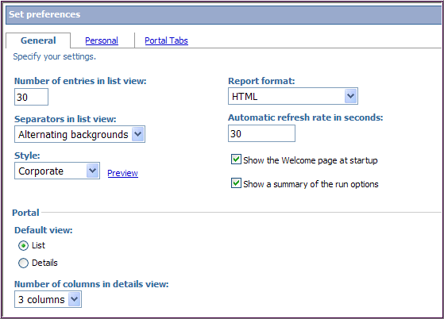
2. Change settings according to your preferences and click OK

Separators in list view - Change to Alternating backgrounds to make the List View easier to use.

Style – the color scheme of Cognos can be changed if you want. The Preview link will let you see what the choices look like.

- No Data Contents option
  - You can quickly determine if your report “failed” due to a lack of data
  - This option works with all types of reports (Lists, Crosstabs, Charts, etc.)
  - This must be done individually to each report
  - Click any part of the work area
  - In the Properties pane, click the Select Ancestor button

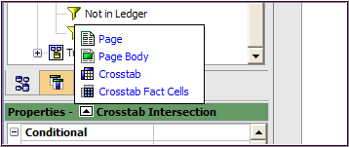
This is the Select Ancestor button

- Click the main report, such as Crosstab or List or Chart
- In the Conditional category, set No Data Contents to Yes
- You will now see two tabs in the work area:

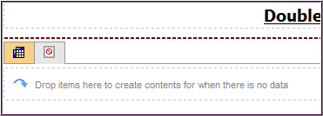
Right tab is the No Data Contents tab
Left tab is the Report tab

- In the Insertable Objects pane, click the Toolbox tab
- Drag a Text Item to the area that says “Drop items here to create…”
- Type the message you want to appear, such as “No Data Found”
- You may want to change the font color and size of the text to be more obvious
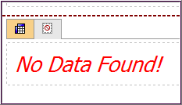

- Save often! – The browser will display the Report name or New with an asterisk when you have not saved recent changes.

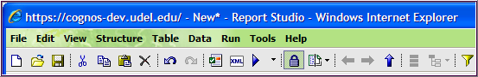

- More about Filter Expressions

a. Add Text to an expression with this syntax (text stands for whatever you want to include):

[space] + [space] ’text’ [space] + [space]

b. Learn about building expressions
- Click the Filter button
- In Available Components, click the Functions tab

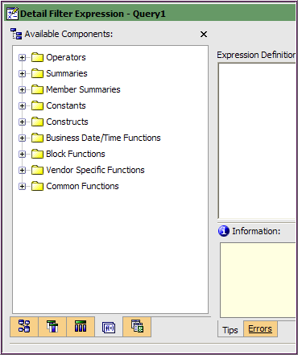
Functions tab
- Open one of the yellow content folder to see the list of functions
- Click on one of the functions
- The Information panel will display the syntax and other useful information about using that function
- For example this is the information for the Summaries function percentage:

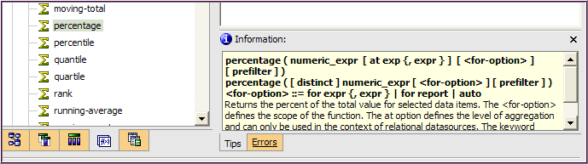

- Crosstabs – how to add rows, columns and measures correctly
  - Rows
    - Drag and drop first field into the Rows area
    - Drag a second field to the right of the first one; when you see the long thin blinking line drop it

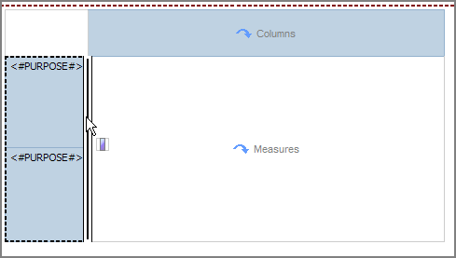

    - Drag a third field to the right of the 2nd one; when you see the medium thin blinking line, drop it.

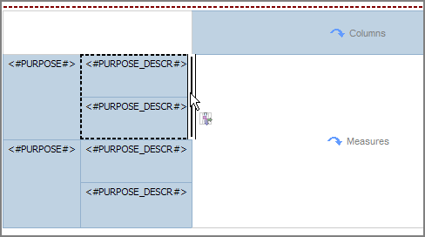
- Columns
  - Drag and drop first field into the Columns area
  - Drag a second field below the first one; when you see the long thin blinking line, drop it

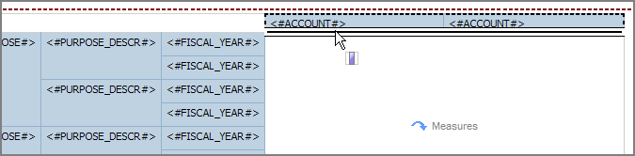

    - Drag a third field below the 2nd one; when you see the medium thin blinking line, drop it.

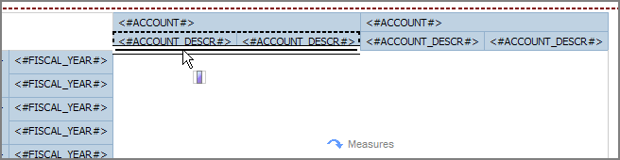

- Measures
    - Drag a “number” field (such as an amount) to the Measures area

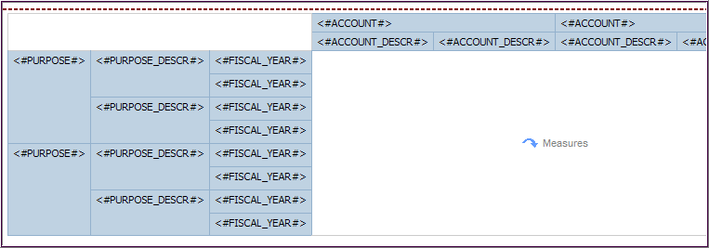

- Use Pickup Style icon (eye dropper) to copy formatting from one text to another
  - Highlight the text with the style you want to “copy”
  - Click the Pickup Style icon

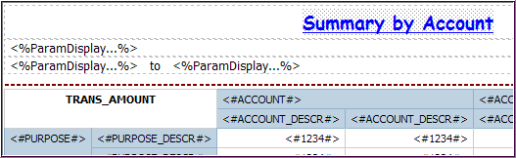
- Highlight the text you want to take that style (control-click to highlight multiple text fields)

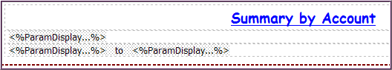

- Click the Apply Style icon

- Add a Data Item Expression to a field (this is not a FILTER, do not use )

IF THEN ELSE

This is an alternative to the Join example A, shown in Advanced Topics (pages 1-8).

  - Open Report Studio with UOD Trans Detail and Balances package with a new List
  - Add these fields to your work area:

Field Name | Query Subject | Folder
ACCOUNT | Chart of Accounts | Account
ACCOUNT_DESCR | Chart of Accounts | Account

  - Add the pre-written prompt Purpose Prompt to your report
  - Add the pre-written Filters to your report
    - Open Filters folder and double-click to add these three:
      - ACTUALS Ledger Filter
      - Journal ID not blank Filter
      - Statistics Code exclude Filter

  - Add a Filter to include just the years 2008 and 2009:

[UOD Trans Detail and Balances].[Trans Detail].[FISCAL_YEAR] in (2008,2009)

  - Click Toolbox tab
  - Click Query Calculation and drag it to the right side of work area (look for long thin blinking line)
    - Name it FY2008
    - Enter this expression:

IF ([UOD Trans Detail and Balances].[Trans Detail].[FISCAL_YEAR]= 2008) THEN ([UOD Trans Detail and Balances].[Trans Detail].[TRANS_AMOUNT]) ELSE ( 0 )

  - You may want to copy this expression for the next step
  - Validate (correct any errors) and click OK

  - Click and drag another Query Calculation to the right of the first one

  - Click Query Calculation and drag it to the right side of work area (look for long thin blinking line)
    - Name it FY2009
    - Enter this expression:

IF ([UOD Trans Detail and Balances].[Trans Detail].[FISCAL_YEAR]= 2009) THEN ([UOD Trans Detail and Balances].[Trans Detail].[TRANS_AMOUNT]) ELSE ( 0 )

  - Validate (correct any errors) and click OK

  - Save the report and name it Alt 2FY Totals by Account

  - Add another Query Calculation from the Toolbox to the right of the FY2009 column
    - Name it % Diff
    - Enter this expression using the fields from the Data Items tab:

([FY2009]-[FY2008])/[FY2008]*100

  - Validate (correct any errors) and click OK

  - Save
  - Run the report
Note – Use the Function tab in the Expression window to help you write your expressions. This is an example of
- Click the Functions tab
- Open the Constructs folder
- Double-click if then else to add it to the Expression Definition
- A template will appear; you will replace the phrases <condition> and <expression> with your own fields and expressions
- The Information box will give an example to follow.

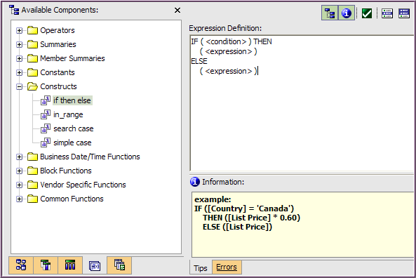

- Converting a List to a Crosstab

  - Choose the fields you want to become the columns in the Crosstab
    - They must be adjacent fields
    - Shift-click the first and last column titles to select multiple fields

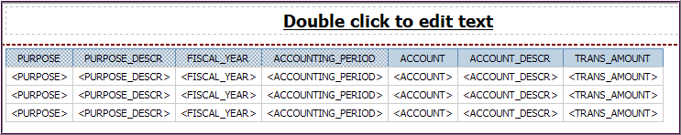

  - In the Toolbar, click Pivot List to Crosstab

  - Your work area will look something like this:

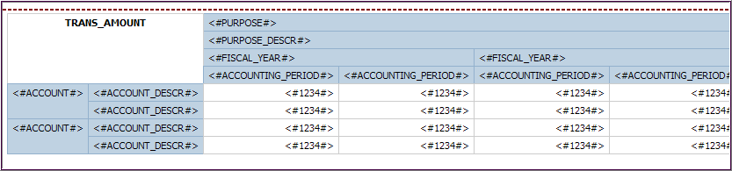

  - OPTIONAL - You can switch the columns and rows with Swap Columns and Rows in the toolbar

- Converting a Crosstab to a List
- Click inside the Crosstab in the work area
- Use Ancestor button in Properties to select Crosstab

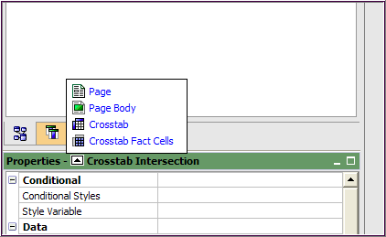

- Click the Cut button (not delete) – the work area is now blank

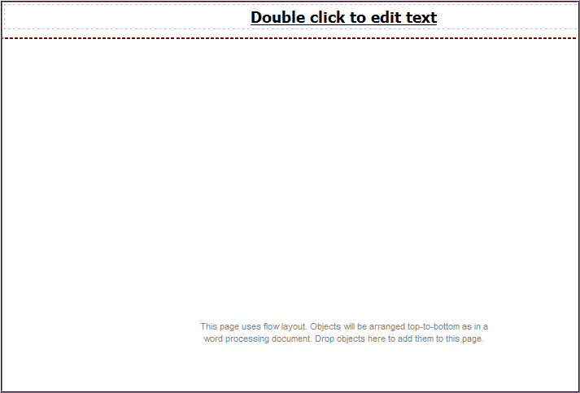

- Click the Toolbox tab
- From the Toolbox tab, drag a List to the work area

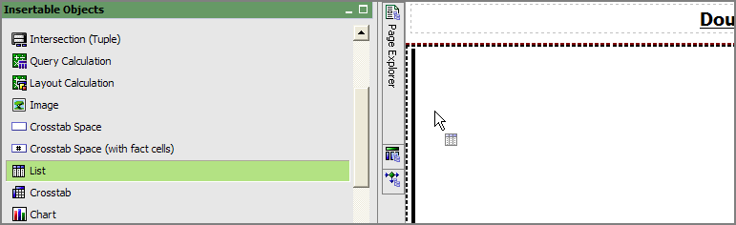
- Click the Data Items tab
- Click Query1
- Drag & drop Query1 to the list (this will add all the fields in Query1 to the List)

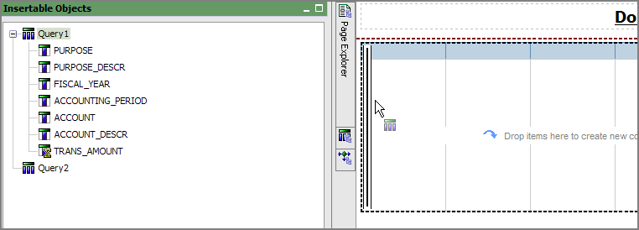

- Click on the List
- Use the Ancestor button in Properties to select List

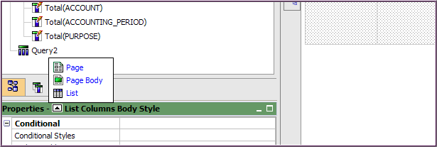

- In Properties, go to Data/Query – change Query2 to Query1

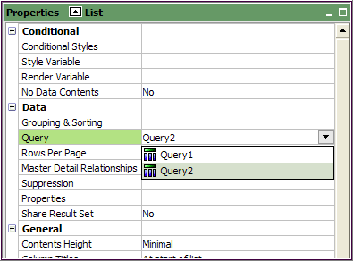

- All your fields are now in the list; change the order of the fields as needed
- Save your work
- Adding Images to a report (from a web page)
  - Make a place to hold the image (in this example – the header area)
    - From the Toolbox, drag a Block under the title and drop it when you see the blinking line on the right side of the title box

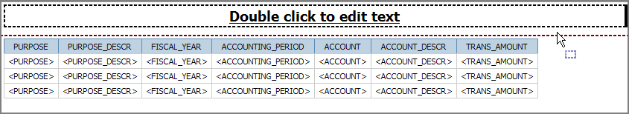
    - Then drag a Table into the Block and drop it when you see a blinking line on the left side of the block
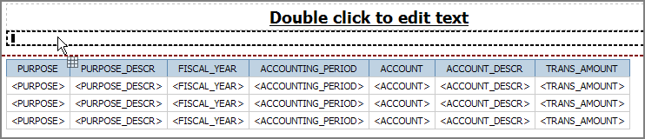
    - Make the Table 2 Columns and 1 Row
    - Click OK
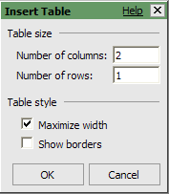
  - Still in Toolbox, drag an Image to the right cell of the Table
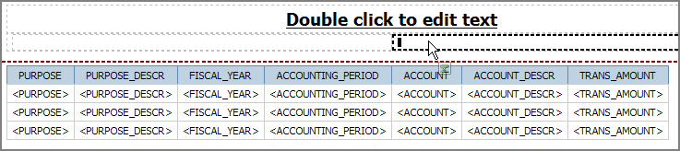
    - Highlight the cell and click the Center button in the toolbar

  - Open another browser session
    - If have an image already chosen, go to its URL
    - OR go to www.udel.edu/PR/UDaily/small%20images/
      - A list of images will appear, click on the links to find one you like
      - Click the image and copy the URL
  - Go back to your Cognos report
  - Click the Image in the work area and go to Properties
    - Under URL Source, click URL and then click the Ellipses
    - In the Image URL window, paste the URL of your image and click OK
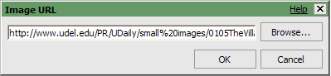
- Your work area will look like this
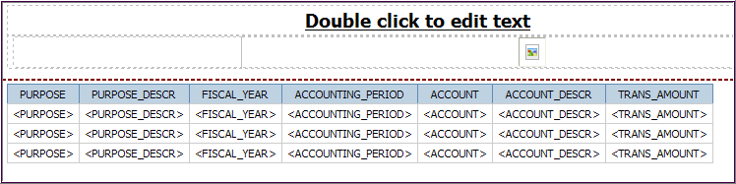
  - Save your work

- Add Row Count to header
  - From the Toolbox:
    - Drag a Block under the title
    - Then drag a Table into the Block
    - Make the Table 2 Columns and 1 Row
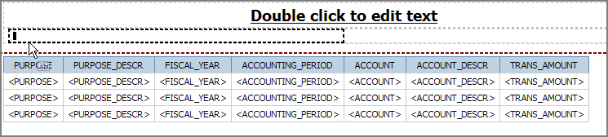
  - From the Toolbox, drag a Text Item to the left table cell
    - Type No. of Rows: [space] in the Text window
    - Click OK
  - From the Toolbox, drag a Query Calculation to right table cell
- Call it Row Count
- Click OK

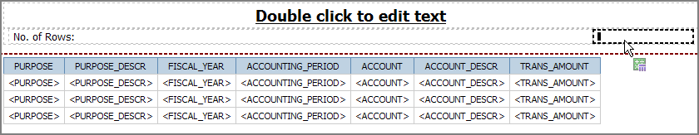
  - Create the expression
    - In the Expression box, type: count(
    - Click the Queries tab and double-click PURPOSE to add it
    - Type ) after the Purpose field
    - The expression should look like this:
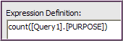
    - Validate and click OK
    - This message will appear, click OK
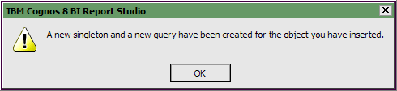
  - From the Toolbox, add Row Number to the report to verify your row count, drop Row Number to the left of the first column when you see a thin blinking line
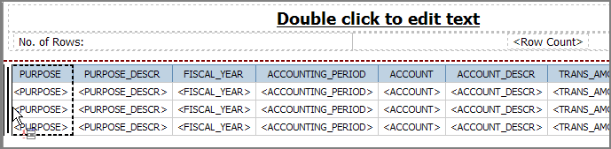
  - Save and Run the report
NOTE – If you are not getting the same Row Count as the number of rows when you run your report, there are two possibilities.

First, you may need to use the Bottom link to see the end of the report.

Or second, you may have additional fields in your query that are not displayed in your report. This happens when fields are Cut from the work area in Page Explorer, but still exist in the underlying query. Go to Query Explorer, look for and delete un-needed fields. See the next item called “Cut vs. Delete.”

- Adding more fields to a Repeater
  - In the work area, click on Repeater where you want another row or column
  - In the menu bar, click Table and choose Insert
  - Choose either Table or one of the Column or Row options
  - Enter number of Columns and/or Rows desired
  - Drag and drop new field(s) into the new box(es)
  - You may need to add Text Item(s) if you have labels in your repeater

- Add Purpose description when header has a dynamic title for Purpose
  - From Toolbox tab, drag & drop a Singleton next to the Purpose <%ParamDisplay…%>
  - From Data Items tab (Chart of Accounts, Purpose folder) drag and drop PURPOSE_DESCR into the Singleton
  - Go to Query Explorer, click Query2
  - Add the Purpose Prompt to Detail Filters
- Remove Footer from report before downloading to Excel
Date, time and page number defaults into the footer of every report. These fields are problematic when you download to Excel and use the Sort feature.

  - Click Headers & Footers button in the toolbar
  - Click on Header & Footer
  - Click OFF the footer checkbox

- Use Cognos Connection to find a recent report

First Method - Date Modified column
- Go to specific folder or sub-folder in Cognos Connection, in this example My Folders and then GA Cognos Class
- Click the Modified column twice
- This will bring most recently changed reports to the top of the list

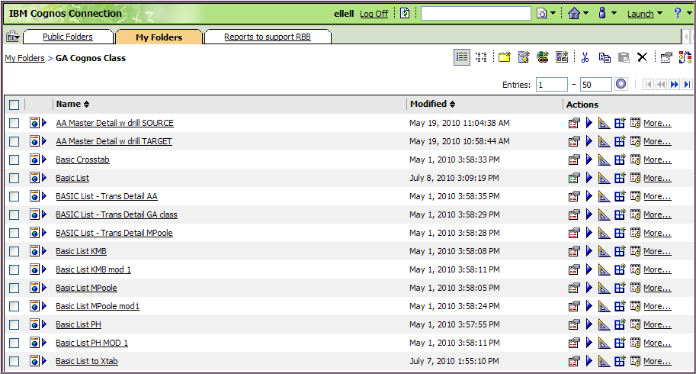
Second Method – Use Search box
- Go to specific folder or sub-folder in Cognos Connection, such as My Folders
- Click the Search button without entering anything in the box

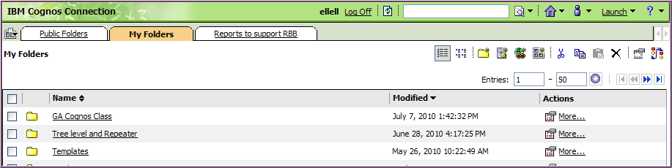

- Click Advanced

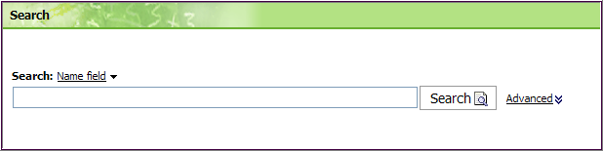

- This will give you additional search criteria, the two most useful are:
  - Modified is the date last modified
  - Scope is what folders to search

- Click the downward arrow , these are the choices for (date) Modified:

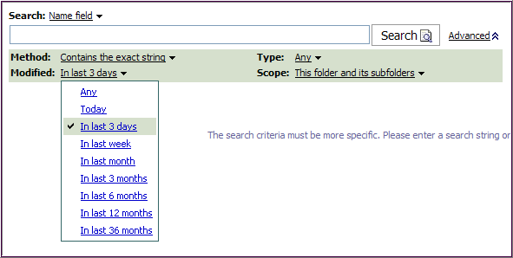

- Click the downward arrow , these are the choices for Scope:

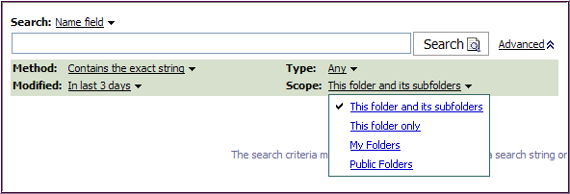

- After setting the criteria, click Search

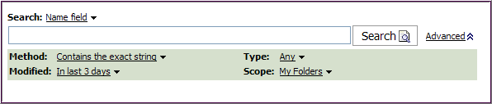

- Find your report from the list; use the Actions open it (Report Studio )

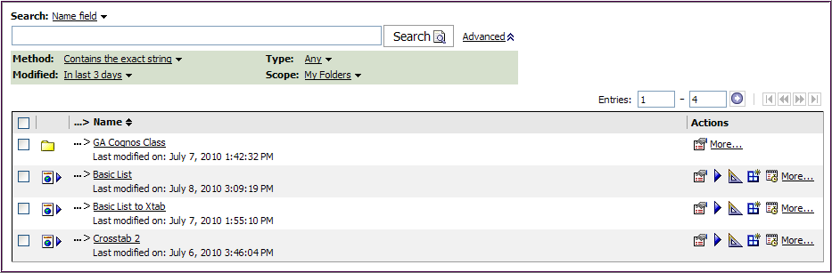

- Download to Excel without changing your computers settings or if your computer runs on Windows 7
  - Run a report and chose Excel 2007 (or other version of Excel)
  - When the hour glass appears that indicates the report is running
  - HOLD the CTRL key until Excel opens

- Caution for any field with this icon (builder's square) is a number and is auto-aggregated in Cognos.

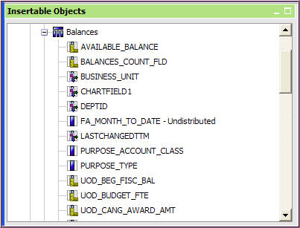

  - When using the field in a Filter , change the Application setting to "after auto aggregation" to get valid results

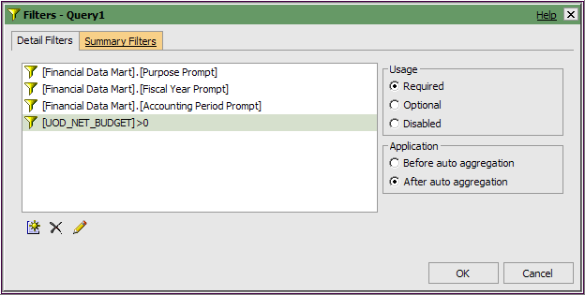

- How to add more rows or columns to a table (this includes Repeater tables)

  - Click on the table cell where you want to insert the row or table

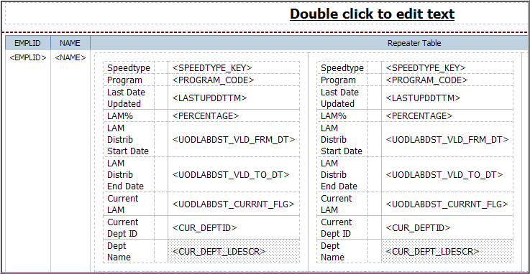
This is an example of a Repeater Table

  - Go to the Table menu item

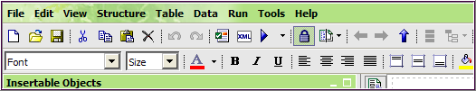

  - Select Insert
  - Select Columns… or Rows… as needed

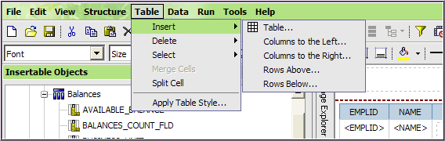

  - Enter the number of columns or rows you want and click OK

